Tao Folder moi: ViewModels

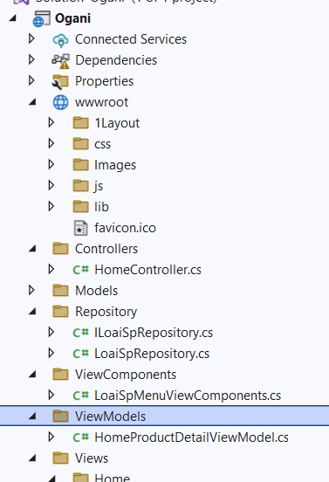

Them class: HomeProductDetailViewModel

using Ogani.Models;

namespace Ogani.ViewModels

{

public class HomeProductDetailViewModel

{

public TDanhMucSp danhMucSp { get; set; }

public List<TAnhSp> anhSps { get; set; }

}

}

Sang HomeController:

public IActionResult ProductDetail(String masp)

{

var sanpham = csdl.TDanhMucSps.SingleOrDefault(x => x.MaSp == masp);

var anhsanpham = csdl.TAnhSps.Where(x => x.MaSp == masp).ToList();

var homeProductDetail = new HomeProductDetailViewModel

{

danhMucSp = sanpham,

anhSps = anhsanpham

};

return View(homeProductDetail);

}

Add view:

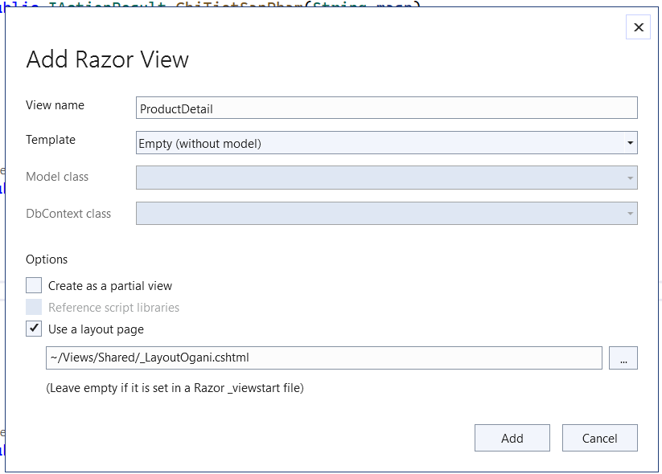

@{

ViewData["Title"] = "ProductDetail";

Layout = "~/Views/Shared/_LayoutOgani.cshtml";

}

@model Ogani.ViewModels.HomeProductDetailViewModel

<!-- Product Details Section Begin -->

<section class="product-details spad">

<div class="container">

<div class="row">

<div class="col-lg-6 col-md-6">

<div class="product__details__pic">

<div class="product__details__pic__item">

<img class="product__details__pic__item--large"

src="@Url.Content("../Images/"+Model.danhMucSp.AnhDaiDien)" alt="">

</div>

<div class="product__details__pic__slider owl-carousel">

@foreach (var image in Model.anhSps)

{

<img src="@Url.Content("../Images/"+image.TenFileAnh)" alt="">

}

</div>

</div>

</div>

<div class="col-lg-6 col-md-6">

<div class="product__details__text">

<h3>@Model.danhMucSp.TenSp</h3>

<div class="product__details__rating">

<i class="fa fa-star"></i>

<i class="fa fa-star"></i>

<i class="fa fa-star"></i>

<i class="fa fa-star"></i>

<i class="fa fa-star-half-o"></i>

<span>(18 reviews)</span>

</div>

<div class="product__details__price">@Model.danhMucSp.GiaLonNhat</div>

<p>

@Model.danhMucSp.GioiThieuSp

</p>

<div class="product__details__quantity">

<div class="quantity">

<div class="pro-qty">

<input type="text" value="1">

</div>

</div>

</div>

<a href="#" class="primary-btn">ADD TO CARD</a>

<a href="#" class="heart-icon"><span class="icon_heart_alt"></span></a>

<ul>

<li><b>Availability</b> <span>In Stock</span></li>

<li><b>Shipping</b> <span>01 day shipping. <samp>Free pickup today</samp></span></li>

<li><b>Weight</b> <span>0.5 kg</span></li>

<li>

<b>Share on</b>

<div class="share">

<a href="#"><i class="fa fa-facebook"></i></a>

<a href="#"><i class="fa fa-twitter"></i></a>

<a href="#"><i class="fa fa-instagram"></i></a>

<a href="#"><i class="fa fa-pinterest"></i></a>

</div>

</li>

</ul>

</div>

</div>

<div class="col-lg-12">

<div class="product__details__tab">

<ul class="nav nav-tabs" role="tablist">

<li class="nav-item">

<a class="nav-link active" data-toggle="tab" href="#tabs-1" role="tab"

aria-selected="true">Description</a>

</li>

<li class="nav-item">

<a class="nav-link" data-toggle="tab" href="#tabs-2" role="tab"

aria-selected="false">Information</a>

</li>

<li class="nav-item">

<a class="nav-link" data-toggle="tab" href="#tabs-3" role="tab"

aria-selected="false">Reviews <span>(1)</span></a>

</li>

</ul>

<div class="tab-content">

<div class="tab-pane active" id="tabs-1" role="tabpanel">

<div class="product__details__tab__desc">

<h6>Products Infomation</h6>

<p>

@Model.danhMucSp.GioiThieuSp

</p>

</div>

</div>

<div class="tab-pane" id="tabs-2" role="tabpanel">

<div class="product__details__tab__desc">

<h6>Products Infomation</h6>

<p>

@Model.danhMucSp.GioiThieuSp

</p>

<p>

@Model.danhMucSp.GioiThieuSp

</p>

</div>

</div>

<div class="tab-pane" id="tabs-3" role="tabpanel">

<div class="product__details__tab__desc">

<h6>Products Infomation</h6>

<p>

@Model.danhMucSp.GioiThieuSp

</p>

</div>

</div>

</div>

</div>

</div>

</div>

</div>

</div>

</section>

<!-- Product Details Section End -->

Sang PartialSanPham

<h6><**a** **asp-controller**="Home" **asp-action**="ChiTietSanPham"

**asp-route-maSp**="@Model.MaSp">@Model.TenSp</**a**></h6>

